# Tools of the Trade – Homework

For this homework, we are going to familiarize ourselves with some tools that we will be using throughout the semester. If you haven't already, please ensure that you have completed the Tools of the Trade - Lab before attempting this homework.

Git

If you are not familiar with version control and the reasons for using it, watch the following video (<https://www.youtube.com/watch?v=M-O8ZNW9icQ>) and take 15 minutes to complete this tutorial: <https://try.github.io/levels/1/challenges/1>.

For a more complete documentation and reference on Git, bookmark the following guide on Git and refer back to it as necessary: [https://www.atlassian.com/git/.](https://www.atlassian.com/git/) It is a comprehensive and easy to understand guide on Git.

Shell

We use the shell to interface with our computer through the operating system and tell it to do something. For this class, we are using the Bash shell, there are other types of shells available such as, ZSH or Fish, however, for what we are going to be using in this class, Bash will work for us nicely.

Using your preferred text editor, create a hw1.txt file in your IOLab code repository, under the hw1 directory. In your hw1.txt file, type which bash command you would use to perform the following tasks:

Example: Change file permissions: chmod 777 filename.txt

1. Change Directory
2. Create a Directory
3. Rename a Directory
4. List the contents of a directory
5. Move a file to a new location
6. Copy a file to a new location
7. Search for a string in a file
8. Access the shell of a remote machine

We have not covered all of the above in class, but you should be able to find the answers relatively easily by searching for them on Google. You should get comfortable searching Google and Stack Overflow or the relevant documentation to find answers to questions like above.

## Submitting Your Homework

You are going to submit your homework via Git. Using the shell, navigate to your IOLab directory. If you are in the correct directory, you should be able to run “git status” and see something like below:

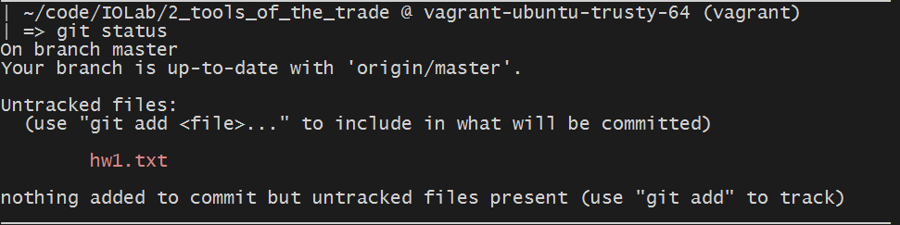

Before you add the homework and submit it, first create a new branch by running:

git checkout –b hw-1-branch

After you create a branch, stage the hw1.txt file, commit, and push the changes to your repository. You can do that by running the following commands:

git add .

git commit –m “submitting hw1”

git push origin hw-1-branch

As a final step, navigate to your repository on Github. You should see something similar to this page, click on “Compare & Pull Request”.

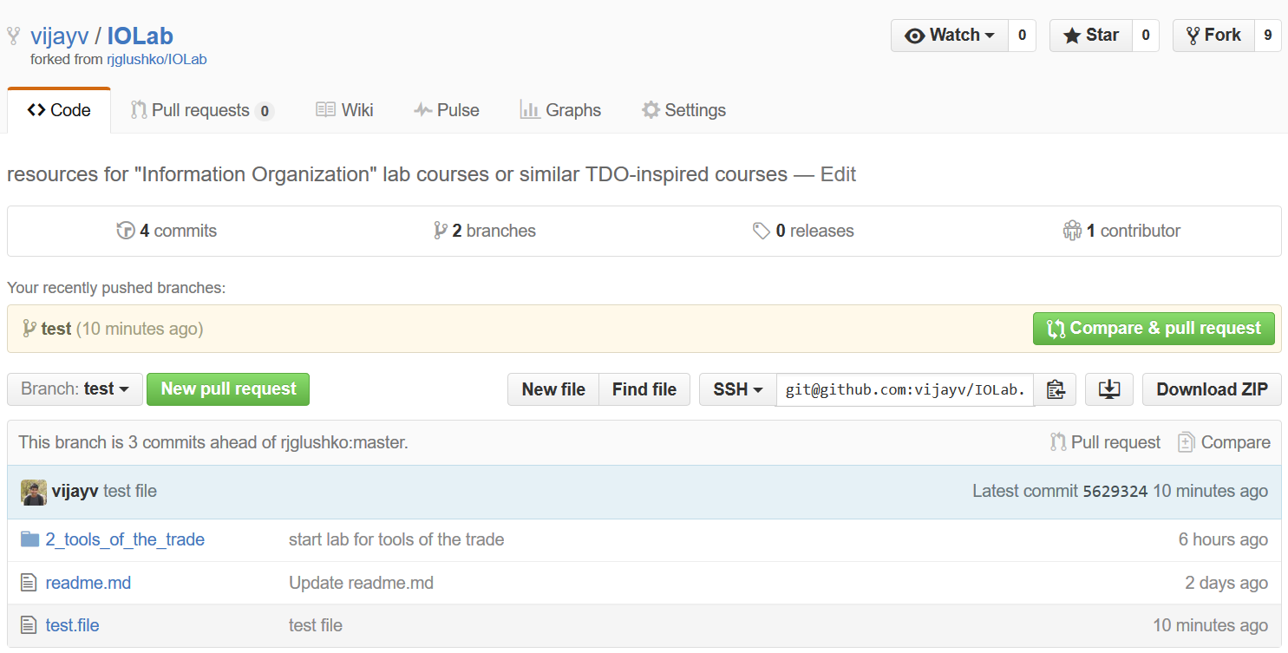

In the following page, you will see something similar to below:

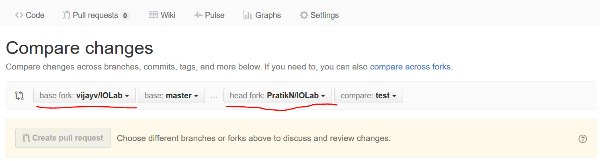

Ensure that you select the base fork as “vijayv/IOLab” and select the head fork as your own, and the branch to hw-1-branch. Finally, you can click “Create Pull Request” to submit your homework.

** The reason for turning in your code in this manner is because it allows to give you pointed feedback on your code inline. This is a common practice in the industry and is formalized through a process called a code review. If you are interested, you can read more about it here: [http://blog.codeship.com/github-code-review/.](http://blog.codeship.com/github-code-review/)